Design Updates
URL:
http://us15.campaign-archive2.com/?u=12a794b2402eb103cba5c25f4&id=e75049d821
- Post my Flight Button - Button needs to be moved further left aligned with red line
Currently:
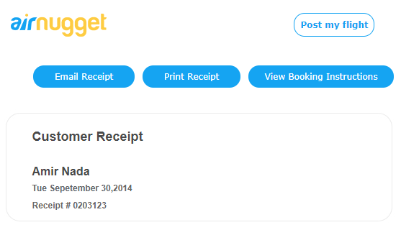
Updated:
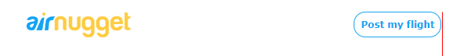
- Email button needs to be resized and aligned with red line
Currently:
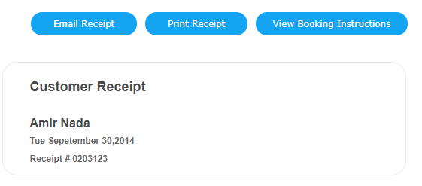
Update: Please follow same design as in provided designs
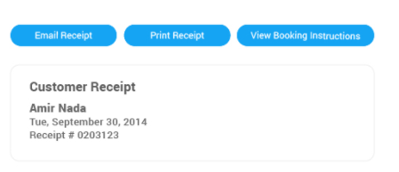
- Remove Itinerary details – delete text in red
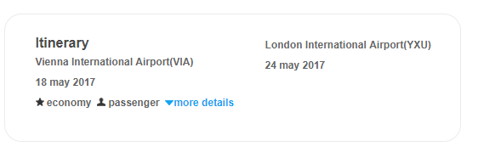
- Move Payment Details text and align with other headings – red line
Currently:
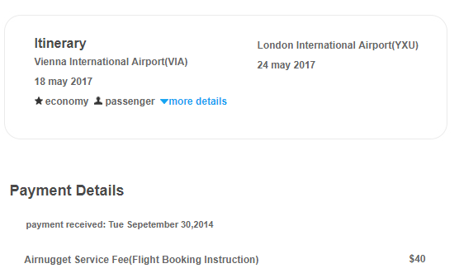

Update
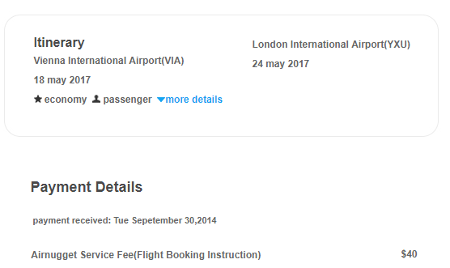

- Update text
Current:
to
Payment received:
- Update link

https://plus.google.com/116469662694192725459/about

